Function Practice Programs

1. Create a program to check if a given string is a palindrome using recursion.

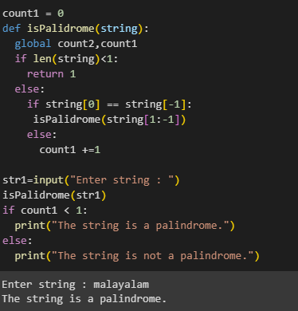

1. Generate the Fibonacci series up to a specified number of terms using a function (non-recursive)

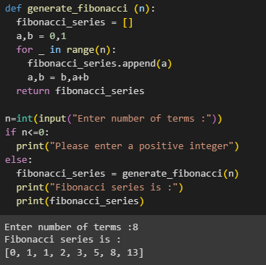

1. Create a function to reverse a given string.

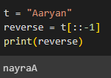

1. Write a program to check if a given number is prime or not using a function.

